**Den Hung**

The 8th to the 11th day of the third lunar month

Hung Temple festival is held again at Hung Temple, Viet Tri city, Phu Tho province

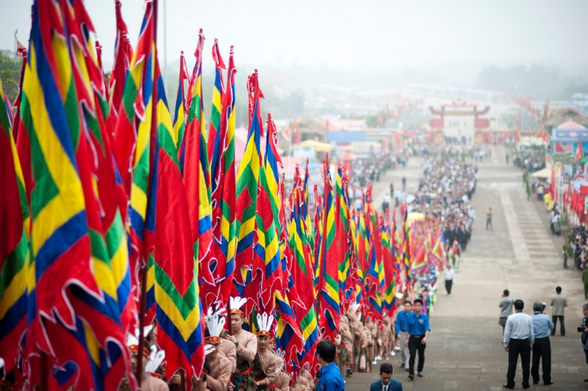

The purpose of this ceremony is to remember and pay tribute to the Hung kings who are the traditional founders and first kings of the nation. The festival began as a local holiday, but has become recognized as a national holiday starting in 2007. In 2016, the total number of visitors to the festival numbered seven million.

## ****The Ceremonies in Hung King Temple Festival****

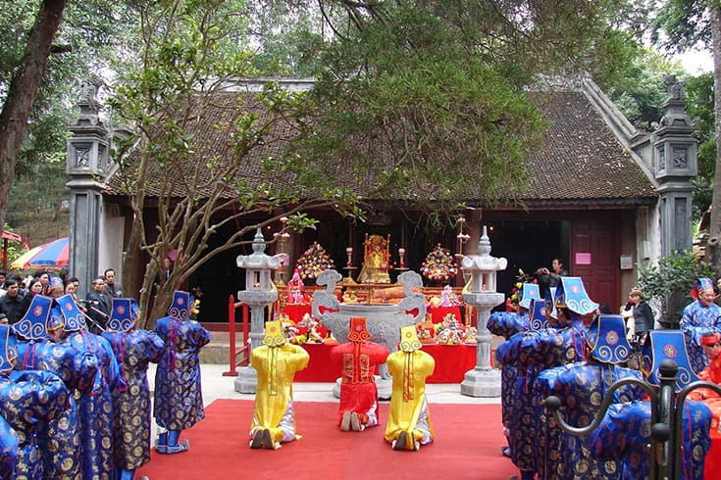

The Hung Temple is an ancient and sacred architectural ensemble on the top of the 175 metre-high Nghia Linh mountain. The festival offers an opportunity for Vietnamese to visit their land of origin.

A day before the festival, ancient and modern flags are to be hung along the road leading from Viet Tri to Hung mountain. A large balloon will also publicise the festival to surrounding areas. On the eve of the festival, 100 flying lights are released into the night sky.

The main worship service is held in earnest the following morning, 10th day, beginning with a bronze drum performance with the participation of around 40 different villages. Next, an incense-offering liturgy will be displayed in order to hold the solemn national ceremony.

In Den Thuong (Upper Temple) where the Hung Kings used to worship deities with full rituals, the ceremony consists of a lavish five-fruit feast. Bánh Chưng (square cake) and banh giay (circle cake) are also served to remind people of the Lang Lieu Legend (the 18th Hung King who invented these cakes), and the merit of the Hung Kings who taught people to grow rice.

Next to the stage procession for deities, there are several marches in the procession such as the elephant march followed by the procession chair.

## ****Activities at Hung King Temple Festival****

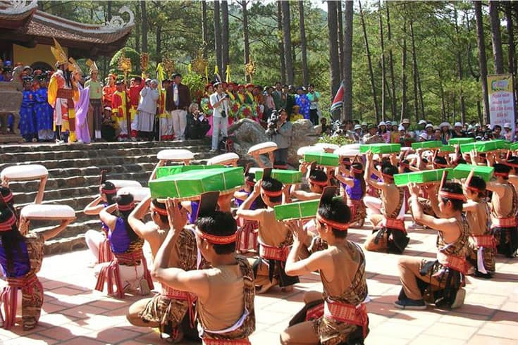

In Hung Temple Festival, there are a wide range of folk games including bamboo swings, rice cooking competitions, sacred ball throwing through a ring, [human chess](https://vietnamdiscovery.com/culture-arts/human-chess-in-vietnam/), wrestling, lion dance, crossbow shooting, water puppet performance and so one. Each of the games plays an important part in the bustling ambiance of the festival, which appeal a huge participation of so many people.

The local residents often perform the “gheo” and [“xoan” singing](https://vietnamdiscovery.com/culture-arts/xoan-singing/) during the festival. Besides, other art demonstrations are also displayed beautifully on stage.